 Who to contact
To
- Request a Speech and Language review of your aid
- Report a fault
- Arrange to return the aid
Contact
Speech & Language Therapy
University Hospital North Durham
North Road
Durham
DH1 4LT

Tel: 0191 333 2591

Email: communication-aids@nhs.net

Multi-Award Winning
Speech & Language Department
 European Society of Swallowing disorders
2014
 UK Acquired Brain Injury Award for Innovation
2014
 Chairmans quality Award 2014
Making a Difference Award 2014
 Dragons Den Trust Award 2014
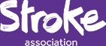 Highly recommended Professional Excellence
2013
 Award for Personalisation 2012

Contact details
Speech & Language Therapy
Merrington House
Spennymoor
County Durham
DL16 7UT
Tel: 01388 825700
 www.cddft.nhs.net
 Find us on Facebook
Let us know your thoughts,
www.patient.experience.cddft.nhs.uk
Date Published: 14/03/16
Date of Review: 14/03/18
Responsibility: Clinical Lead Communication
Reference No: Communicationaid1
Version: 001
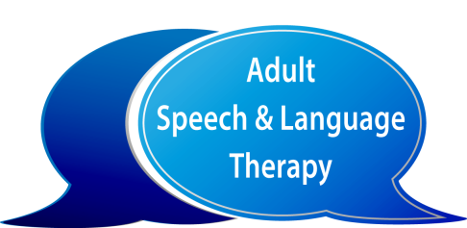
Communication Aid Loan Contract
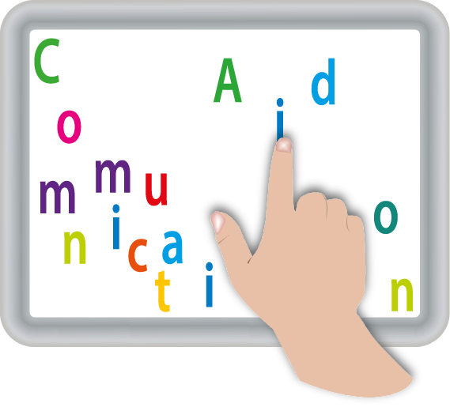A copy of this contract will be
Patient Name:
D.O.B:
NHS number:
Address:
- Given to the person loaning the aid.
- Stored in the Speech and Language File.
You have been loaned a communication aid:

Name of aid

Serial Number

Issue Date

Length of loan

Accessories

Approximate Value

This aid is designed to
help support your communication.

This aid is on loan from
County Durham & Darlington NHS Trust.

By signing this contract you consent to personal data (as required to support your communication) being stored on this device.
You are fully responsible for the content added to the device.

Patient Name:
D.O.B:
NHS number:

The
Speech and Language Therapist will:

- Set up the aid for you.
- Teach you how to use it.
- Answer your questions.
- Contact you every 6 months to review your use of the aid.
- Ensure the device is completely wiped of all your personal data upon its return.
Signed
Speech and Language Therapist
Date:

You are agreeing to:
- Maintain the aid, including keeping it charged and clean.
- Allow Speech and Language Therapy unconditional access to the device as required.
- Reply to any correspondence.
- Contact the Speech and Language Therapy Department if you:
  - Have issues with the aid.
  - No longer require the aid.
- Replace the aid in the event the aid is lost, damaged or stolen. The Trust will invoice you in order to recuperate the cost of the aid.
You are strongly advised to add the aid to your home insurance policy.

Signed
Client / Advocate
Date:

